**Department of Counseling - San Francisco State University**

**Instructions for Applicants - Submitting Letters of Recommendation**

Please review these instructions carefully before contacting your Recommenders or completing your online application. These instructions provide you with information that is necessary in arranging your Letters of Recommendation as well as using the online CAL STATE APPLY online application process for submitting the letters. This is the only way Letters of Recommendation can be submitted.

Note that two (2) professional reference letters are required. These reference letters should be written by people who have supervised you in a relevant professional experience or in an academic capacity (i.e., professor or supervisor).  **Only two letters of reference**will be accepted. If you submit more fewer than 2 letters, your application will be removed from consideration.

Letters of Recommendation must be submitted online through the CAL STATE APPLY application process. When you begin to complete the CAL STATE APPLY Application, you will input the names and email addresses for your two Recommenders. Make sure they have consented to serving as Recommenders prior to submitting their names. You may do this before you have completed the full application.

Once you have entered your Recommenders’ names and email addresses into CAL STATE APPLY, they will receive an email from the CAL STATE APPLY portal inviting them to submit their letter to the portal. They can submit their letter on their own letterhead, or if they wish, they can use the form we have provided here.

In writing your Letter of Recommendation, if your Recommender would prefer to use our form rather than their own letterhead, please use the **Recommendation Form**. **Be sure to fill in your name, degree objective/specialization and emphasis (if any) on each form before emailing it to your recommender.** This is essential so that the person writing the reference can tailor their comments to reflect your particular strengths related to your desired program. Note: All letters of recommendation must be submitted using the professional’s letterhead or our form.

Whether the Recommender uses our form or their own letterhead, please ask that they address the following questions:

* In what capacity have they known you?
* How long have they known you?
* Your Recommender should comment on the following qualities:
  + intelligence, creativity, cultural self-awareness, understanding of sociopolitical and structural concepts, openness to new ideas and feedback, organization, timeliness, ability to grasp and communicate conceptually, ability to work collaboratively, etc.
  + interpersonal sensitivity, cultural humility, cultural responsiveness, openness to feedback, ability to tolerate ambiguity and discomfort, interest and insight into psychological factors in human functioning, etc.
  + experience and understanding related to marginalized individuals and communities (e.g., Black, Indigenous, Latinx, Asian American, Pacific Islander, South Asian, Arab, and other communities of color; LGBTQIAA communities, people with disabilities).
* The Recommender should provide their overall estimate of your potential as a graduate student and professional counselor, address situational factors that should be considered in the review process, and indicate if there are any other special indications that we should consider in the admissions process (personal maturity, stability, motivation, integrity, etc.)
* The Recommender should also rate your overall promise (poor, marginal, average, good, outstanding)

**Cal State Apply Application for Graduate Admission – Letter of Recommendation Process**

1. Student designates the individuals who will write their Letters of Recommendation.

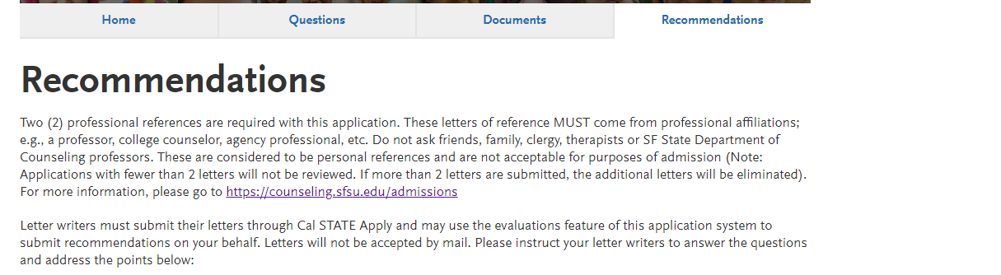

1. Student adds email address and message and waives (or does not) rights

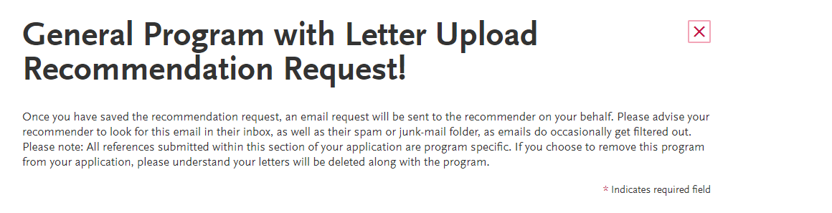

1. Letter writer (Recommender) is notified by email with instructions
2. Recommender must register and then fill in Likert type rating form and upload a document (letter):
3. 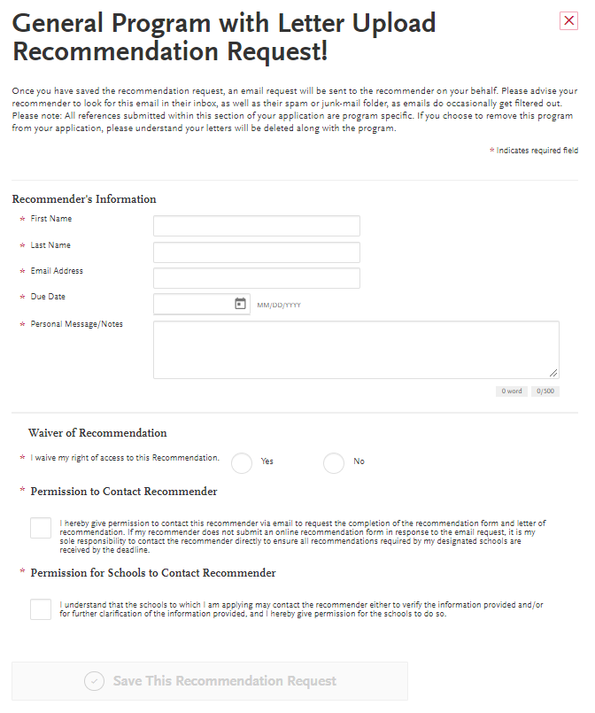The Recommender receives confirmation of submission